Operator Compliance Follow-Up Form Instructions

The MS4 Stormwater Compliance Inspector will provide the form in both Word and PDF formats. To add photos to the PDF version, you must have at least Adobe Acrobat DC Standard or equivalent. The free Adobe Acrobat Reader will not allow you to add photos. Only one format is required, please select whichever format is easier for you to complete the following. iPads or other tablets may be used if the operator has programs such as “PDF Expert.” Please contact your MS4 Stormwater Compliance Inspector for help using such programs.

The operator will fill out all information at the top of sheet one. In both PDF and Word, the operator should be able to click on each blue/grey field and type in the response. The Stormwater Compliance Inspector will be able to answer any questions regarding project information. Please be sure to enter the correct dates for the compliance inspection and for the operator compliance follow up inspection.
PDF:
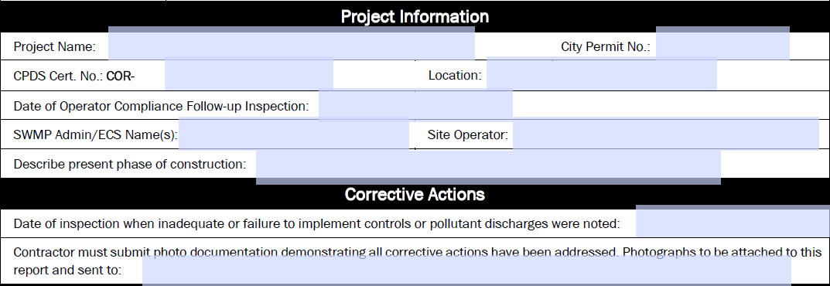
Word:
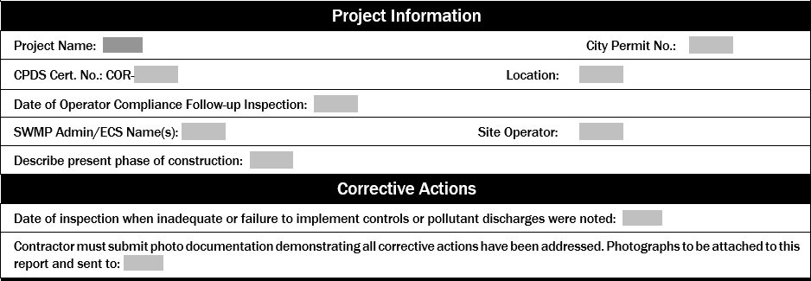
For each non-compliance issue identified by the MS4 Stormwater Compliance Inspector, a corrective action description is needed on the first page (or second page if necessary). Again, the operator should be able to click on the blue/grey field and type in the response. Please be sure to list the descriptions in a similar order to the compliance inspection.
PDF:
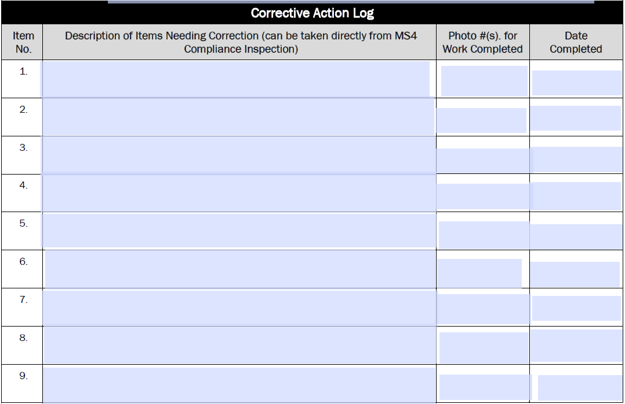
Word:
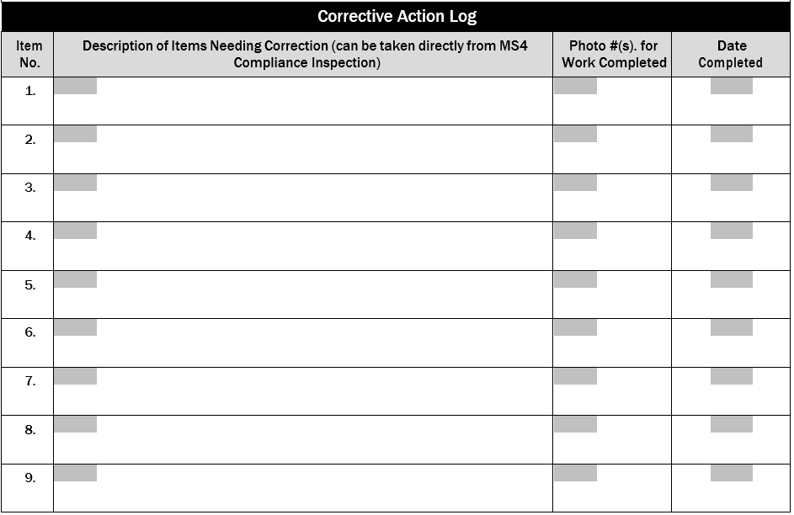

Remember to add the operator’s name and date at the end of this section.
PDF:
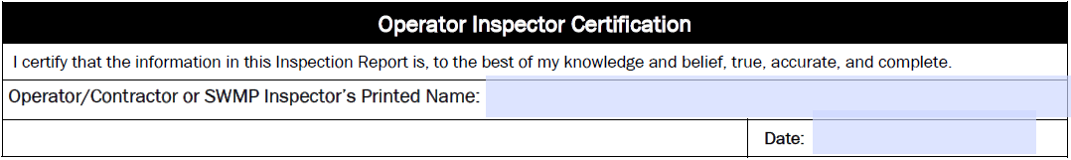
Word:
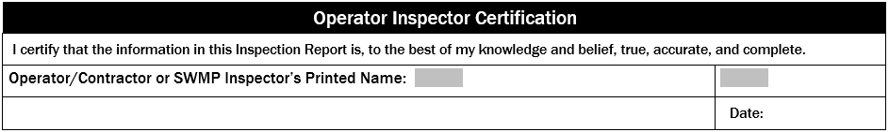

Lastly, the operator will need to upload photos. Remember these photos should be taken at approximately the same spot as the photos from the compliance inspection. This will help show that you have addressed the finding in the manner that the inspector requires. If the photo does not completely show the finding addressed, the inspector may ask for additional photos to be sent, and may even need to come back onsite for a follow up inspection. Remember to list the photos in the same order as the compliance inspection. The area below each photo is for any descriptions or comments regarding the above photo (this can be copied straight from the compliance inspection).
PDF:
Click on Edit PDF
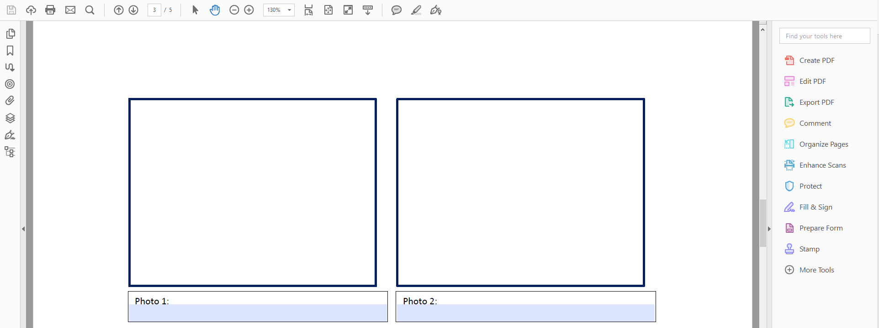

Click on Add Image

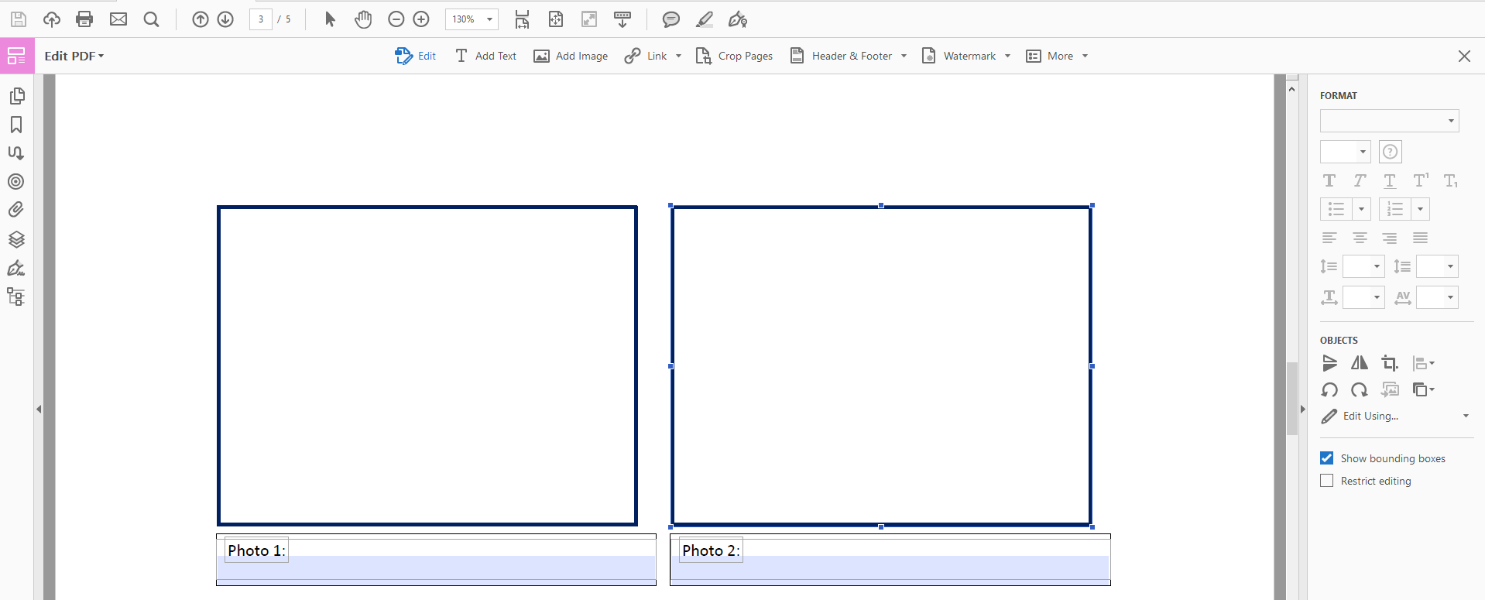
After clicking “Add Image” a box will open to ask you to identify which photo you would like to add. The options will differ depending on your computer and operating system. However, generally you will need to find where the photo is located on your computer and then double click on the link to the photo, this should drop it into the document. You may need to move and adjust the size to fit inside the box.

Word:
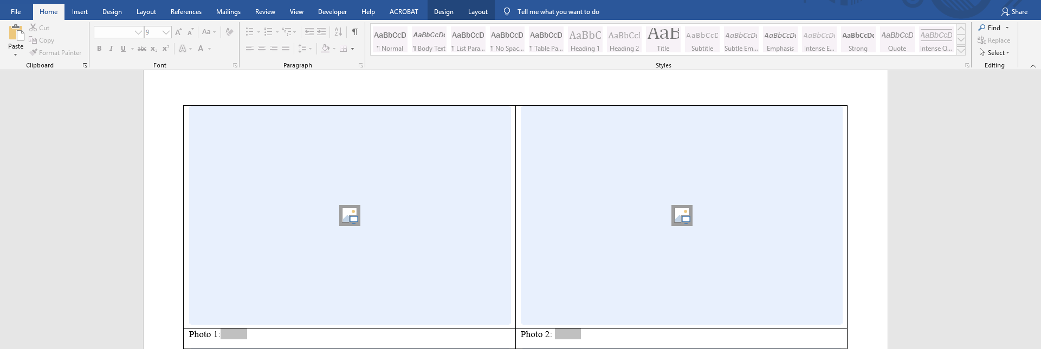
Click on the Photo icon
After clicking the photo icon, a box will open to ask you to identify which photo you would like to add. The options will differ depending on your computer and operating system. However, generally you will need to find where the photo is located on your computer and then double click on the link to the photo, this should drop it into the document. You may need to move and adjust the size to fit inside the box.
If you use the Word formatted form, please convert the file to a PDF when you save. See below for instructions. If you are unable to convert, please ask your MS4 Stormwater Compliance Inspector for assistance.
Click on “File”

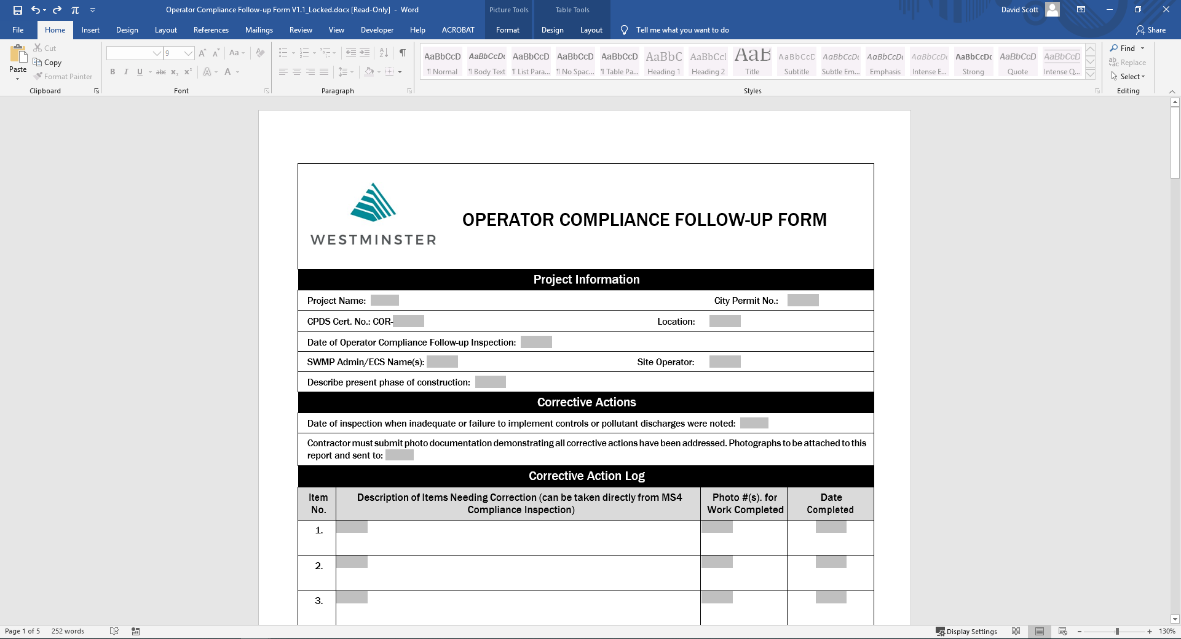
On the left-hand side of the page Click on “Save as Adobe PDF”

