

**Stormwater Management Program News**

City of Cañon City

P.O. Box 1460

128 Main Street

Cañon City, CO 81215-1460

(719) 276-5265

Restaurant Business Edition 2021

**LANDSCAPING TIPS**

* Grass clippings should be bagged for disposal or composted to create natural fertilizer. Leaving grass clippings on the lawn can help add natural fertilizers as they decay.
* Never blow, sweep, or place grass clippings or other yard waste in the street along the curb. Runoff from storm events or over-irrigation of lawns can wash the clippings or other waste into the nearest storm drain or culvert, leading to blockages of flow and localized flooding. If the waste makes it through the storm sewer system, it will be washed into the Arkansas River where it may cause issues such as algae blooms or other impacts to wildlife and recreation.
* Use fertilizers sparingly and only as the manufacturer directs. Excess fertilizer will just wash off the lawn and into the storm system; again potentially causing water quality problems in the Arkansas River and other drainages. Excess fertilizer in our waterbodies can lead to algae blooms which impact wildlife, recreation, and drinking water.

With many of our local restaurants adding outdoor seating during the past year we’d like to provide some tips for minimizing potential impacts to stormwater runoff and subsequently the water quality of our local waterways. Stormwater runoff enters the storm sewer system, which includes City streets, and flows directly to our local waterways, including the Arkansas River and Four Mile Creek. It is not treated before reaching the river or creek so any contaminants it picks up along the way, such as grease, trash and food waste has the potential to be deposited in the river. We hope these tips will help to minimize the potential for contamination of stormwater runoff and encourage business owners to contact the Cañon City Stormwater Program with any questions they may have.

**Trash Disposal**

* Provide trash cans so patrons utilizing the outdoor seating areas can dispose of the trash from their meals. This will help to keep items such as napkins, straws and straw wrappers from being easily blown away.
* Trash cans should be placed where it is convenient for all to use, but not where they may be easily tipped over.
* Secure lids should be provided for the trash can to prevent trash from spilling out.
* Trash cans should be emptied at the end of the day or taken inside the building to prevent wildlife from rummaging in them and spreading trash around.
* If employees are responsible for bussing tables, it should be done as soon as possible to prevent items from being blown away.

**Outdoor Housekeeping**

* Sweep outdoor eating areas often and dispose of the sweepings in the trash.
* Sweep parking areas rather than hosing them down; pick up trash on a regular basis.
* Parking lots and outdoor eating areas can be power washed as long as the wash water does not leave the property and does not enter any storm drains, irrigation clean-outs or drainages. We recommend that a minimal amount of water be used during power washing and that the area be cleaned in small sections, allowing the water to evaporate then sweeping up any sediment or trash left behind. Water can also be directed into vegetated areas as long as they don’t overflow, causing the wash water to run off the property.
* If wet clean-up methods are used, do not use soap in the wash water or use a biodegradable low-phosphorus soap.



**POTENTIAL**

**STORMWATER**

**IMPACTS**

**Fats, Oil and Grease (FOG) Management**

Disposal of fats, oil and grease generated through restaurants’ daily operations can significantly contribute to stormwater runoff pollution if not managed properly. For those businesses that do not use an internal collection system these tips should be considered to properly manage FOG wastes.

* Provide an overhead cover for external grease storage bins to prevent rain from mixing with the contents and possibly overflowing.
* Alternatively, provide secondary containment around the bin in the form of curbing, double-walled tanks or catchment basins or other types of containment to catch spills, drips or overflows.
* Provide a secure cover for the bin and keep it closed when not in use. This, again, prevents rain from mixing with the contents and decreases the chance that wildlife or insects may get in.
* Do not place grease storage bins near storm drains without having secondary containment in place.
* Consider installing a grease/water separator in or near outdoor garbage and grease containers to capture and treat stormwater runoff from that area.
* Make sure the bin is emptied by a contracted grease disposal collector on a regular schedule. Adjust the pick-up schedule as needed.
* Never dump grease, oil, fats or other liquid wastes in a dumpster designed only for solid waste. These dumpsters are not leak-proof.
* Post clear signage on all dumpsters indicating the type of waste they are meant to contain.
* Inspect bins and the surrounding area regularly to assess any needed maintenance or the need to replace the bin.
* Check with the Fremont County Department of Health and Environment on any additional requirements.

**Employee Training**

Employee training is a vital part of preventing potential stormwater pollution. The following items should be considered during training of employees.

* Fats, oils and grease should never be dumped down a sink drain or toilet. These substances will cause clogging of the sanitary sewer which degreasers, solvents or hot water will not remedy.
* Only dry clean-up methods should be used on spills and drips. These can include rubber scrapers, paper towels, absorbents, or kitty litter. Absorbents and kitty litter can be swept up and disposed of in the regular dumpster.
* Educate employees and provide the proper procedures and tools needed to transfer used grease, oil and fats to the storage container.
* Waste water in mop buckets or cleaning containers should never be dumped outside, especially not on pavement. If it is not greasy it should be disposed of in the sink or toilet. If it contains a layer of grease, it may need to have the layer skimmed off and disposed of separately.

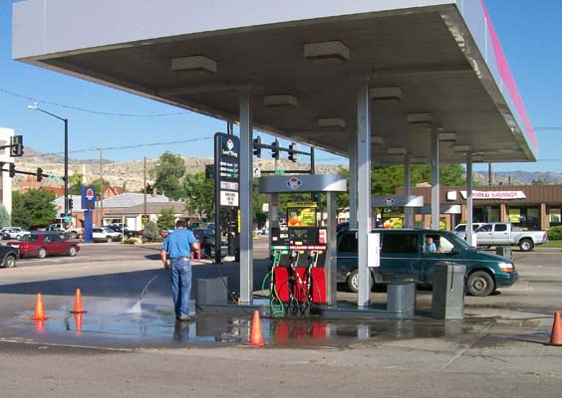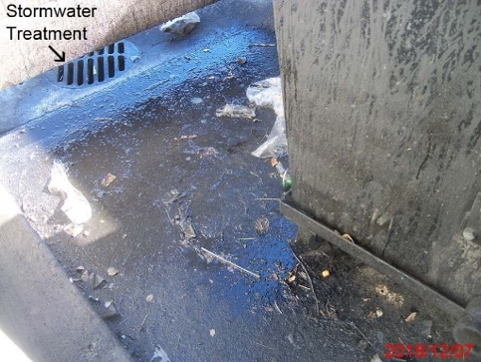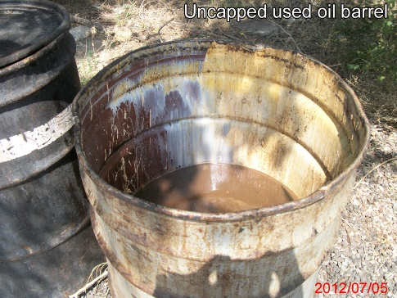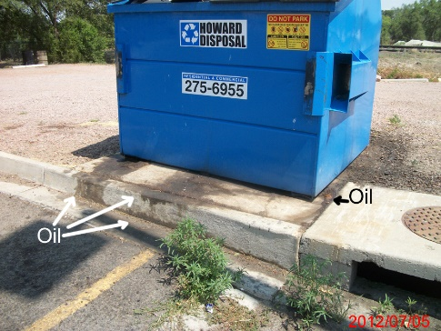

*“When we try to pick out anything by itself, we find it hitched to everything else in the Universe.” – John Muir*

Please feel free to direct any concerns or questions to Glenda DeBekker, City of Cañon City Stormwater Program at either 276-5265 or [grdebekker@canoncity.org](mailto:grdebekker@canoncity.org).

**MINIMIZING**

**POTENTIAL**

**IMPACTS**